The Traditional Churches of Edithburgh host a Monthly
Ecumenical Service
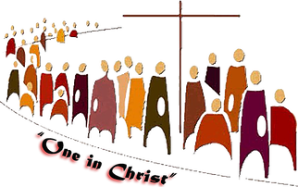
All Welcome
On the fourth Thursday of each month (February – November) members of the Uniting, Lutheran, Catholic and Anglican churches gather to celebrate our shared faith. The service starts at 9:30am and the venue rotates between the churches. Morning Tea follows.
- Thursday, February 27 – Edithburgh Roman Catholic Church
- Thursday, March 26 – Edithburgh Uniting Church
- Thursday April 23 – Edithburgh Anglican Church
- Thursday, May 28 – Edithburgh Roman Catholic Church
- Thursday, June 25 – Edithburgh Uniting Church
- Thursday, July 23 – Edithburgh Anglican Church
- Thursday, August 27 – Edithburgh Roman Catholic Church
- Thursday, September 24 – Edithburgh Uniting Church
- Thursday, October 22 – Edithburgh Anglican Church
- Thursday, November 26 – Edithburgh Roman Catholic Church
Information: reply@anglicansonyorkes.org.au

